Report on the Status of Women in the Physics Department
February 14, 2003
Lorraine Sadler (Co-Director of SWPS)

I. Introduction
Over the past semester, the women in the physics department have met in order to discuss the issues that they face in recruitment and retention of women graduate students in the department. The goal of these meetings was to identify if the department had problems with recruitment and/or retention of women graduate students and how to solve these problems if they did exist.
After talking with Anne Takizawa and gaining statistics on the number of women who were admitted to the department vs. the number who accepted the offer (see figure 1) we find that there is a significant difference in the amount of women who come to Berkeley versus the amount of men who come to Berkeley. 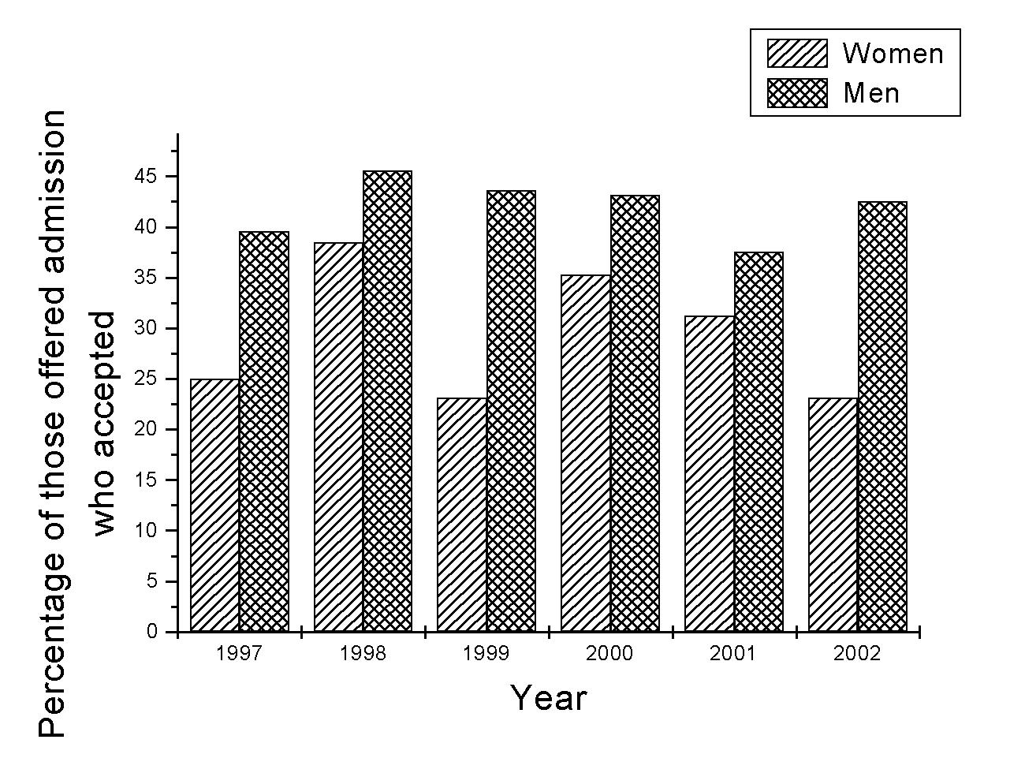
Figure 1: Percent of those offered admission to UC Berkeley who accepted.
The women were particularly concerned about the attrition rate of women once they arrived at UC Berkeley. Statistics were gathered on each entering cohort of students: how many women entered in that year and how many women who entered that year left without a Ph.D. These numbers were compared to the same data for men and were found to be significantly higher (see figure 2).
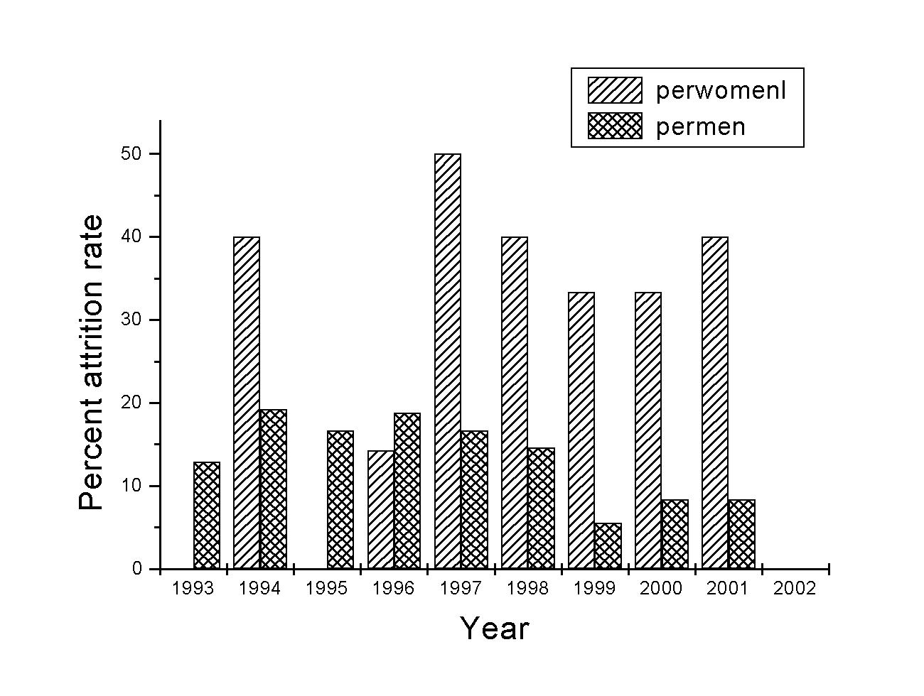
Figure 2: Percent of students in an entering class who left without a Ph.D.

Finally, the women were interested in the gender breakdown of physics Ph.D.’s awarded at UC Berkeley compared to the national average and whether there is an upward trend for women in percent of Ph.D.’s granted or if it was stagnant. In figure 3, we see no such increasing trend. Also, we find that UC Berkeley is consistently lower than the national average for granting women Ph.D.’s by about 5% each year.

By looking at the lack of women at the graduate student level, the women wanted to set a goal for gaining women in physics. Last year, in 2002, the Berkeley physics department graduated 100 B.A. in physics, 26 of whom where women. Currently there are 41 women majors out of 202 declared physics majors in the department, 20%. However, there are only 26 women out of 230 or 11% in the graduate program. They felt that the number of women graduate students should be as a first, minimum goal, equal to the percentage of women undergraduates.
What follows is a short list identifying basic themes the women graduate students feel are causing the above trend of recruitment and retention problems in the physics department. The first section identifies the positive aspects of the department. The next section looks at the areas that need improvement and finally, the last section discusses many ways to improve the physics department, not just for women, but for every member. The following is not complete, but is a beginning to achieve the goals set forth in the previous paragraph.
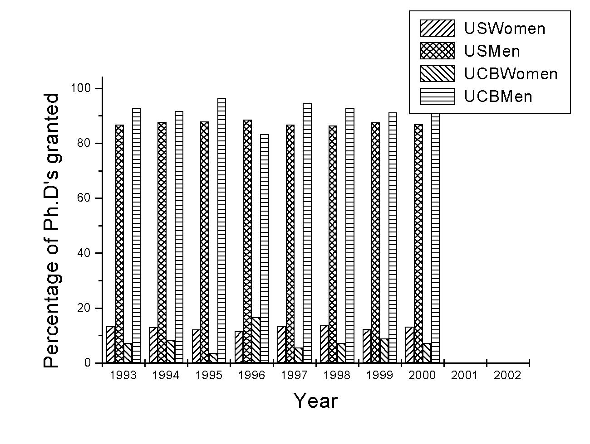
Figure 3: Comparison of the number of PhD’s granted to women and men at UC Berkeley vs. nationally. Source AIP enrollment and degree reports.
- Positive aspects in the physics department.
The women felt that there were many positive aspects in the physics department that created a rich and supportive atmosphere for their education.
- TA offices
- Staff
- Machine shop
- Electronics shop
During the first year, most students found that the TA offices were the center of camaraderie. The office provides a place to gather, talk, discuss, do homework, and have a connection to the department. The staff, especially Anne, Donna and Claudia, was recognized as being a large positive part of the women’s every day. They felt that they cared about the progress of the students and that they would make an extra effort to help out when they could. Anne was particularly mentioned on how hard she worked in order to get students tutors for the prelims.
The two technical shops in the department were also mentioned as important supportive tools to the women. Joseph, the machinist in the graduate student shop, was commended for his ability to help with designs and answer questions. His machining class is seen as a big benefit to many women who have little or no machining background. The class allows for an intensive catch up period so that they can succeed in their own experiments. The rest of the shop was also considered a large asset to many of the women as a good resource to guide in the development of large machinery in their labs. The electronics shop was given high marks. John Davis was seen as an integral part in many experimental designs. The students felt that he treated them with respect and was able to impart a large amount of electronics knowledge to the students. His electronics course during the summer gained the highest marks for usefulness and knowledge gained.

Areas for improvement
At the women’s meeting, four main categories were discussed, which were seen as needing improvement. These areas are:
  - Lack of women faculty and women graduate students
  - Advising
  - Prelims
  - Professional Development

Women Faculty and Graduate Students
The physics department (both at UC Berkeley and nationally) does not have a critical mass of women. The students felt that this was the most pressing issue. The lack of critical mass makes many women feel invisible and trivialized. Their concerns are often overlooked and not addressed.
The lack of women at the graduate level leads to a feeling of loneliness. With only one or two women around in the TA office, women find that the topics of conversations in the first year offices become inappropriate for a workplace environment. With a larger visibility of women in the offices, many of these issues would not surface.
The lack of women at the faculty level leaves a large void in the department for role models for the women graduate students. They feel that this lack of women professors discourages them from think about academia as a career. It is a message to the women that they are unable to make it into the professorial role and many just leave before achieving a Ph.D. or soon after gaining one.
Along the same lines of gaining more women faculty and students, it has been noticed the lack of women colloquia speakers and honored lectureships (i.e. Segre or Oppenheimer lecturer). Women who speak in front of the department change perceptions of a qualified scientist. They allow for networking with the entire faculty and give role models to female students.

Advising
The second issue that the students talked about at length was the lack of advising from faculty in the department. This has two broad areas: 1) advising during the first one to two years before gaining a research advisor and 2) guidance from a research advisor.
The first one or two years of graduate school can be difficult. This is the time when most women decide that they do not want their Ph.D. Most women do not remember who their incoming “advisor” was nor can they remember ever talking with him/her. They felt that they had to make choices on classes (whether to jump into the 221 and 209 classes or 137 and 110), which they had no good basis to make. They also felt that they had no person to talk to about different physics field’s career paths that subsequently went along with these choices. Also, many women felt that they never were advised on the option of going into theory, and that this advice could have changed the outcome of many perceptions of physics.
The second area, lack of guidance from a research advisor comes in two distinct forms, 1) actual technical advising and 2) completion of the Ph.D. The women felt that technical advising, i.e. explaining how a lock-in amplifier works, when they began in their labs was severely lacking. Many felt that they were often thrown into a lab and told to get a particular piece of equipment to work and given no other guidance than this. This state of utter confusion left many students feeling stupid and questioning their ability to be good scientists. In large collaborations, many students feel that they get lost and that their development as students is a far second to gaining results. The second part of advising for students as they traveled closer to graduation was the lack of advice for completion. Many women felt that the time to finishing the experiment Ph.D. is growing due to the lack of advising during the last years when they are ever so close, but not done, with their project. This is one of the major drawbacks women who have B.A. see when they enter the field. They feel that this process is too lengthy and chose another life path.

Prelims
The prelims, as always, are a controversial subject in the department. The women felt that the actual outcome of the prelims do not mesh with the stated goals of the exam. When entering as a first year, it is explained that the prelims are an exam that tests your basic knowledge of general physics. That the exam will cover undergraduate physics. Many tests go beyond the scope of undergraduate physics. Also, it was felt when results were reported that the ranking of students within the class was humiliating and unnecessary. The reality of the exam is that it caused most students to lower their self-esteem and question their ability to do physics. This is a major reason why many women decide not to enroll at Berkeley and why many leave.

Professional Development
The last area that the women discussed was professional development. One of the major issues that women see as a deterrent from physics is the lack of job opportunities in their future. There are few opportunities to gain insight on how to apply for a job, learn how to create their own research project needed to give successful job talks and how to choose the most successful post-doc or job that will propel them to success.

Ideas on how to improve the atmosphere in the physics department

After identifying many issues that were important to the graduate women in the department, the students brainstormed many ideas on how to improve the environment with the goals of recruiting and retaining more women. The following is a short list of ideas that were brought forward.

Hire more women faculty
Although this is a simple statement to write, it is more difficult to complete. There were some good ideas presented to help both find and recruit women. First, there are many women specific job-posting sites that can be used to target qualified women. WIPHYS, a posting site from the committee for the status on women in physics by the APS is one place to start. This can be found on their web site or information about them can be gained by emailing women@aps.org.
The hiring process should also be made more transparent in the department. One-way to help recruit women candidates is to allow them to meet with other women faculty and, due to the lack of women faculty with the women graduate students. This allows the prospective candidate a feeling that there is a support network in the department and that they will not be isolated. Also, the subcommittees that review applications should include students (not only women) such that other views can be heard when deciding whom to bring as a final candidate to the entire faculty. Other ways that can be used to increase women faculty can be found in an article written by Howard Georgi of Harvard at
http://schwinger.harvard.edu/~georgi/women/backpage.htm, which is an article found in the January 2000 Edition of the APS News Online.

Invite Women as Colloquia Speakers and Distinguished Lecturers
The invitation of women as colloquia speakers can be a goal of the department. The APS compiles a speakers list of women by state and field on their website. Departments also qualify for $500 reimbursement for travel expenses for one speaker if more than two speakers are invited within one academic year.
Recruiting women to give talks in the field specific seminars would also gain visibility for women in that field. Women post-docs could be invited early in their work as a first introduction with the thought of recruitment in later years.
Finally, it is important to invite women to give the distinguished lectures (i.e. Regents, Oppenhiemer, Segre, Hitchcock). These lectureships are highly thought of and introduce the public to a new image of outstanding scientists being women.
Some other women who have been suggested for potential colloquia, lecture series or field specific seminars are: Marjorie Olmstead (University of Washington), Margaret Murname (JILA), Shirley Chiang (Davis), Persis Drell (Cornell), Meg Urry (head of the IUPAP Conference) and Cherry Murray (winner of the Marie Geoppert Mayer award).

Institute a more comprehensive advising system in the first years
The advising system to incoming graduate students needs to be improved. Instead of each student choosing their own advisor, each student should be assigned to an advisor who is familiar with the different options for the first years in the department. There should be an initial advising session where the student and the professor examine the past work of the student and decide if they are prepared for the first year graduate classes. The overwhelming opinion about being told that the student is unprepared is that they would rather be advised to take the undergraduate class and succeed then drop out and fail by being pushed beyond what they are prepared for by their undergraduate classes. The advisor should also be prepared to talk to the student about interests and different research options trying to help the student refine their interests and guide them onto the path that will make them most successful.

Give faculty research advisors the ability to share good advising techniques
Encourage faculty to advise their students both in the laboratory and in career goals. Also, have department oversight on lengths of Ph.D.’s and identify ways to shorten the process without jeopardizing graduate education.

Allow students to take the machine shop course and electronics course during their first year
By allowing first year students without an advisor to gain valuable experimental knowledge before going into an intense laboratory setting, the student will gain self esteem and be better trained and seen as a more valuable asset to the hiring professor.

Prelims
The prelim exam should have a stated goal and the test should then meet that goal. This can be achieved by allowing two students to sit on the exam committee and access if the exam really covers undergraduate course work or is outside the scope of the stated goals. Also, when students receive their scores, it is not necessary to rank the student against the rest of the class. The students score, mean, standard deviation, and whether they passed or not is the only information that is needed.

Professional Development
There are two separate ways to increase the professional development of graduate students as a whole. The first way could be to have and publicize books in the physics library on career building, making choices between academia and industry, how to develop a CV, how to balance science and family, and other such topics.
The second very popular suggestion was to bring in panels of speakers to talk about many issues. This has been done in a limited scope in the last couple of years, but there could be more. For example, a panel on how to bargain for the best post-doc would be useful. Also, a series on how to start your own research group/set up a laboratory would take some of the mystery out of joining academia and encourage more women to go down this path. Other useful topics could include: How to get the best deal as an assistant professor/staff scientist/industry worker (a.k.a. how to get the most lab space, set up, benefits, salary…), how to create your own research path and development into a PI, and how to network.

Graduate Student Lounge
One of the most enjoyable parts of the physics department is having TA offices the first year. However, after that year, many graduate students are spread around Berkeley, either at LBNL, Space Sciences, Birge, Le Conte, or other buildings on campus. It is necessary to have a full graduate student lounge. The existing graduate student lounge is not used. It is uncomfortable, has no window, dreary, dirty and most students don’t know where it is or don’t have keys. However, a clean, well-lit room that encourages socialization and a feeling of comfort would allow graduate students, especially ones without an office on campus to have a place to be. This lounge should have a clean refrigerator, microwave, window, tables, chairs, and a couch (although a couch too small to sleep on). This graduate student lounge is even more important now since the SURGE retrofit moved the TA offices out of Le Conte therefore making the graduate students more spread out.

Women’s Bathrooms
There is a lack of women’s bathrooms in the Birge/Le Conte physics complex. Birge is lacking a women’s restroom on the 3rd floor and Le Conte has no restrooms for women on the ground or 2nd floor. However, there are men’s restrooms on every floor. This is important to point out especially when the new physics building is designed, there needs to be equal men’s and women’s bathrooms.

V. Conclusion
The above discussion about how to improve the physics department, increase recruitment and decrease attrition is not completely inclusive. This should be considered a working list and a dialogue between both faculty and students should continue.

