Solar Astronomy: Secrets of the Sun

Fun websites to check out:

→ The latest news about the Sun and Space Weather Conditions:
http://spaceweather.com/

→ See a new amazing astronomy picture every day:
http://antwrp.gsfc.nasa.gov/apod/astropix.html

→ Learn about astronomy, and play games:
http://www.kidsastronomy.com/

Fun places to visit in the Bay Area:

→ Lawrence Hall of Science: Fun exhibits and planetarium. (Berkeley) http://www.lhs.berkeley.edu/

→ Chabot Space & Science Center: Fun exhibits, observatory, and planetarium. (Oakland)
http://www.cosc.org/

→ NASA-Ames Research Center Visitor's Center: 3D Mars Reality Theater. (Mountain View) http://amesnews.arc.nasa.gov/visitorcenter/visitorcenter.html

→ Exploratorium: A hands on science museum. (San Francisco) http://www.exploratorium.edu/

→ Cal Day: Explore the UC Berkeley campus, astronomy lectures and demonstrations, April 17th. (Berkeley) http://www.berkeley.edu/calday

-----------------------------------------------------------------------
The Pinhole Camera:
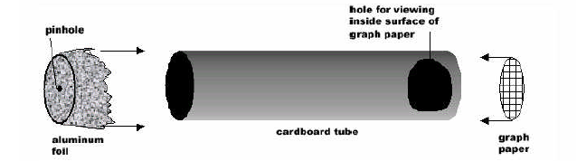

→ Detailed pinhole camera instructions and other fun activities:
http://www.chabotspace.org/vsc/exhibits/solarb/educationresources /touchthesun/default.asp

→ The SOHO (solar observatory) home page: http://sohowww.nascom.nasa.gov/

→ The SOHO image archive: http://soi.stanford.edu/production/int_dk_gifs.html

